Supplementary Information

for

Highly-selective MOF-303 membrane for alcohol dehydration

Jun-Yu Laia, Ting-Yuan Wanga, Changlong Zoub, Jiun-Jen Chenc,*, Li-Chiang Lina,b* and Dun-Yen Kanga,*

a*Department of Chemical Engineering, National Taiwan University, No. 1, Sec. 4, Roosevelt Road, Taipei 10617, Taiwan*

b*William G. Lowrie Department of Chemical and Biomolecular Engineering, The Ohio State University, 151 W. Woodruff Avenue, Columbus, Ohio 43210, United States*

c*Green Energy and Environment Research Laboratories, Industrial Technology Research Institute, No. 195, Sec. 4, Chung Hsing Road, Hsinchu 31040, Taiwan*

Jiun-Jen Chen *E-mail: [JiunJenChen@itri.org.tw](mailto:JiunJenChen@itri.org.tw)

Li-Chiang Lin *E-mail: lclin@ntu.edu.tw

Dun-Yen Kang *E-mail: [dunyen@ntu.edu.tw](mailto:dunyen@ntu.edu.tw)

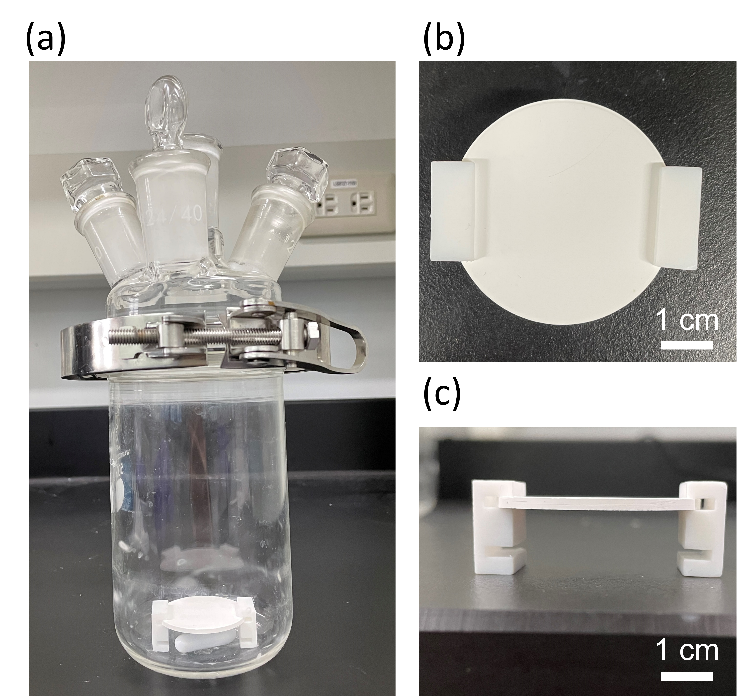

**Fig. S1.** Photographic images of (a) the setup for the secondary growth of MOF membranes and (b) top and (c) side view of the Teflon holder for the alumina substrate.

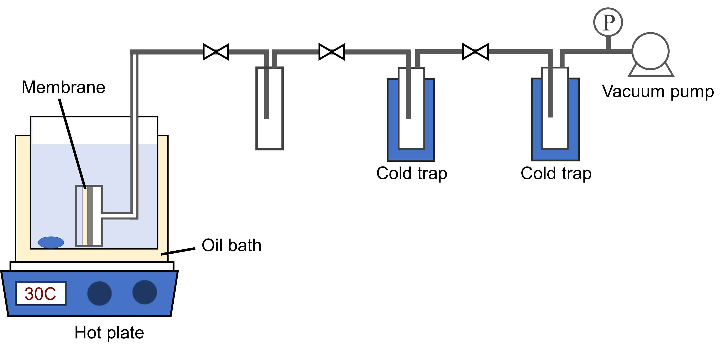

**Fig. S2.** Illustration of the setup for pervaporation tests.

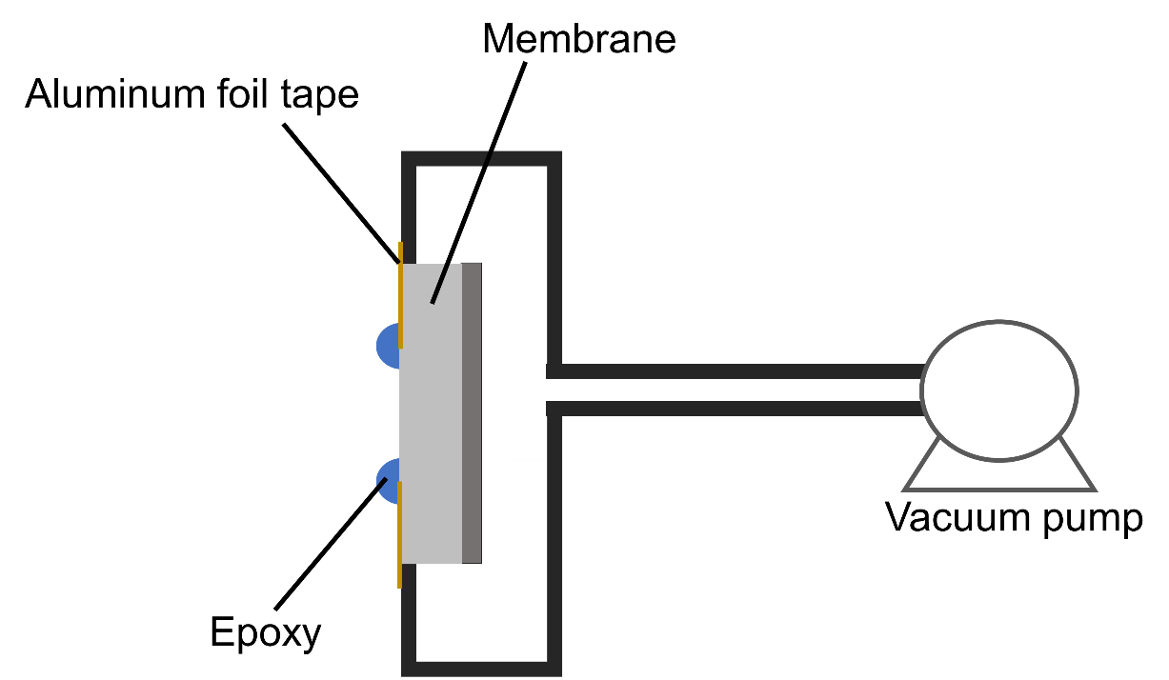

**Fig. S3.** Illustration of the setup for air permeation tests.

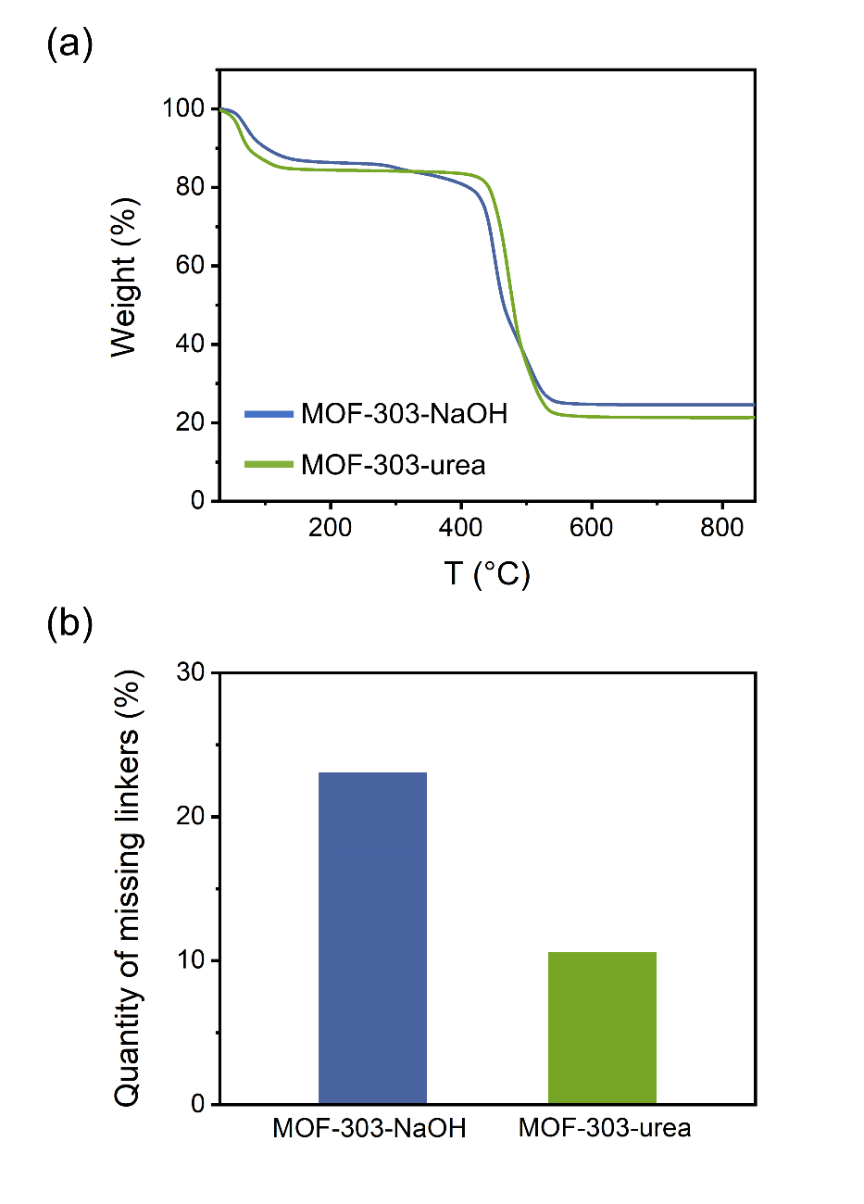

**Fig. S4.** (a) TGA curves and (b) quantities of missing linkers of the MOF-303-NaOH and MOF-303-urea powder.

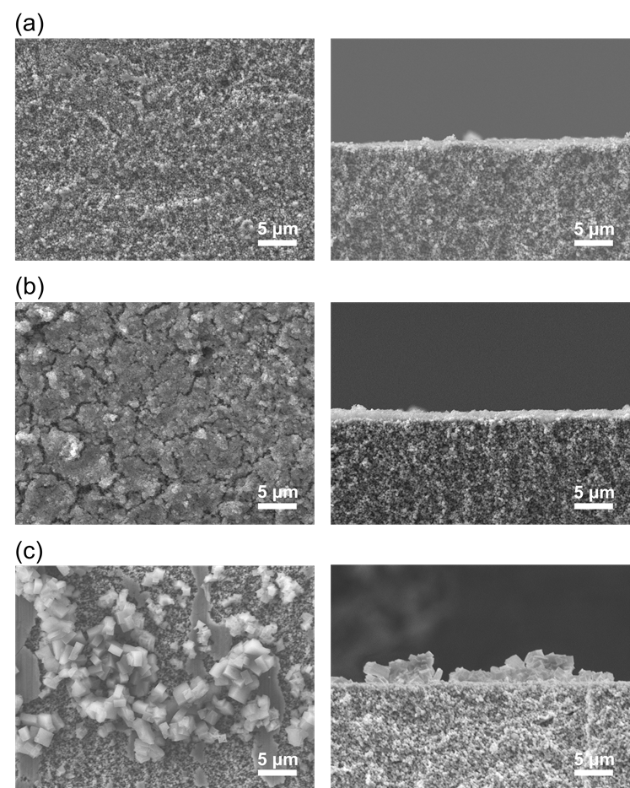

**Fig. S5.**  SEM images of (a) the bare alumina substrate, (b) the seed layer of MOF-303-NaOH, and (c) the seed layer of MOF-303-urea. The top-view images are shown in the left column, and the side-view images are shown in the right column.

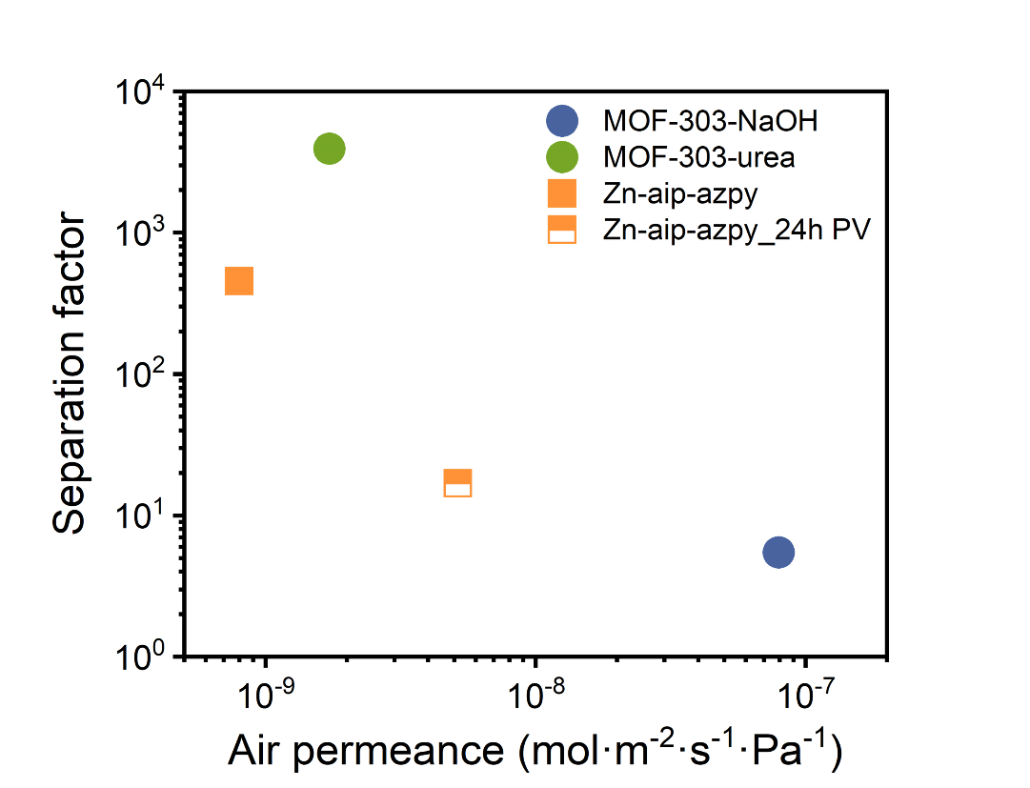

**Fig. S6.**  Water-to-IPA separation factors versus air permeance of MOF membranes. The results of Zn-aip-azpy membranes are acquired from a previous report (ref. [69] in the main text). The air permeance of the bare substrate is approximately 1.63×10-6 mol·m-2·s-1·Pa-1.

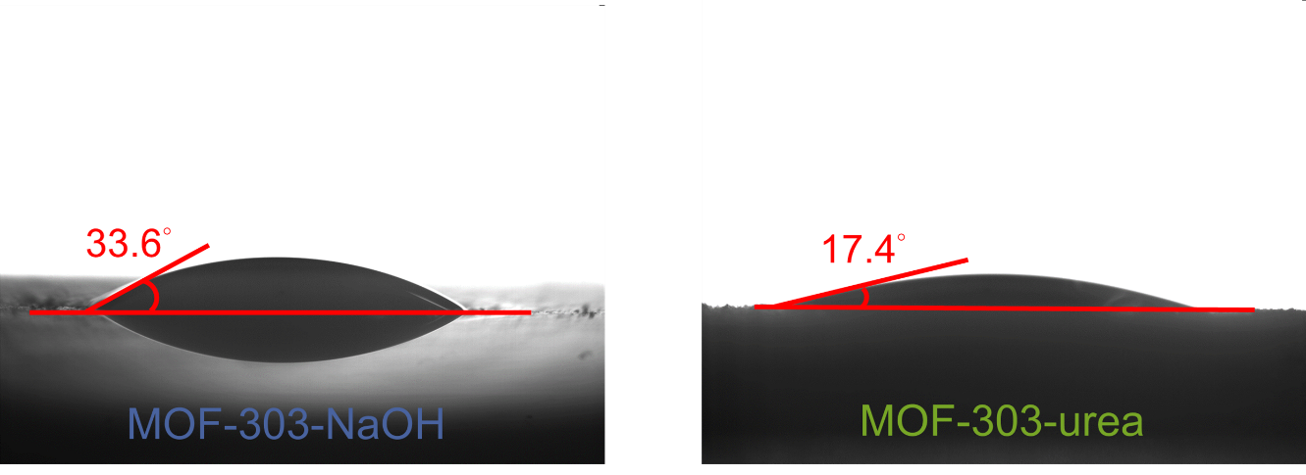

**Fig. S7.** Water contact angles of MOF-303-NaOH and MOF-303-urea membranes.

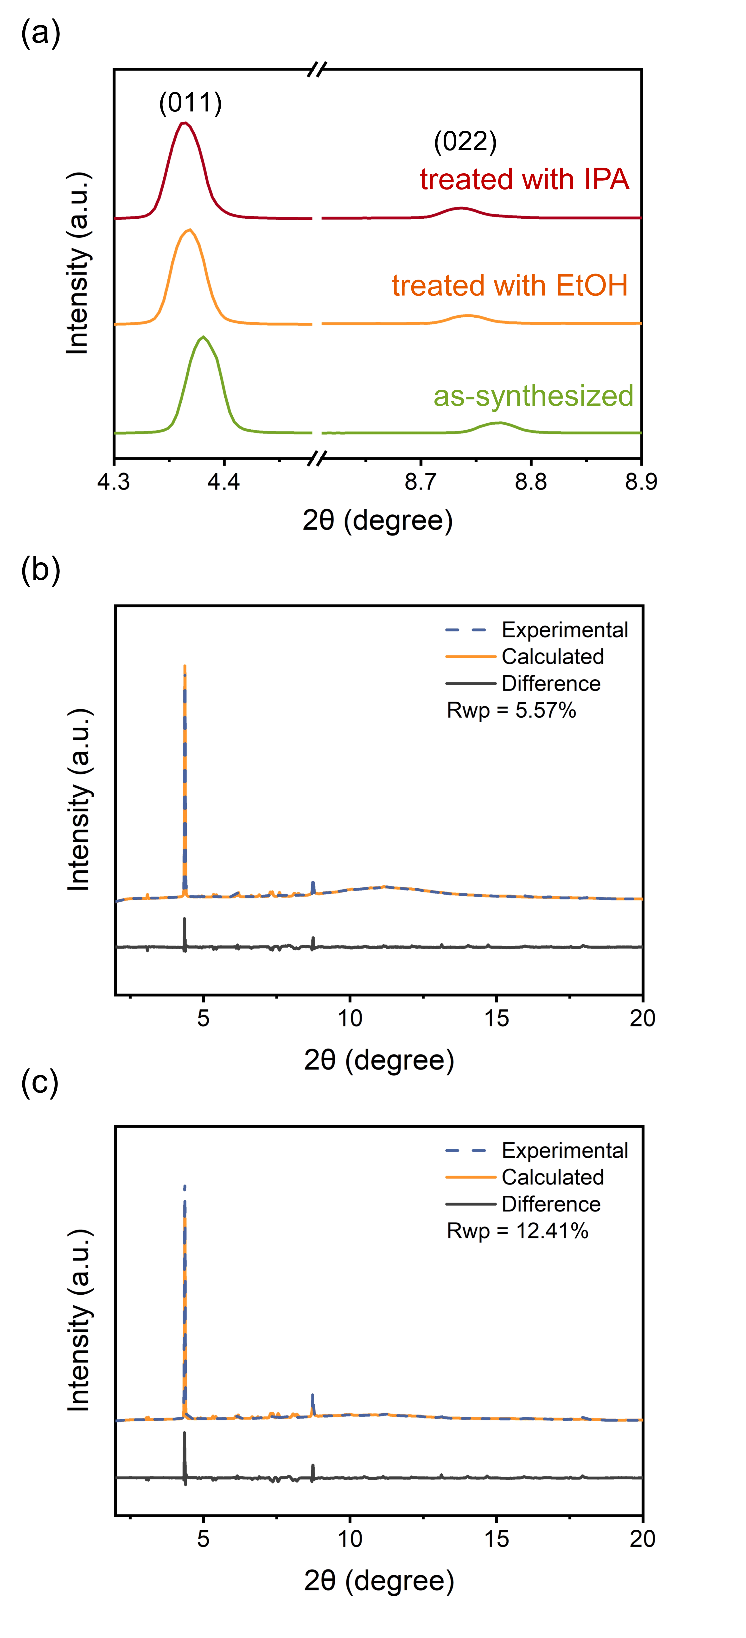

**Fig. S8.** (a) Powder XRD patterns of as-synthesized MOF-303-urea and that treated with 90 wt.% ethanol or IPA at room temperature for 6 days. These XRD patterns were obtained in TPS 19A at NSRRC with X-ray at a wavelength of 0.77489 Å. The results of the Rietveld refinements for the powder XRD patterns from the sample treated with (b) ethanol and (c) IPA. The starting structure for the Rietveld refinement is CCDC #2078717. According to the structures yielded from the refinement, the PLDs of the samples treated with ethanol and IPA are respectively 6.21 and 6.13 Å, whereas the as-synthesized MOF-303-urea has a PLD of 5.84 Å.

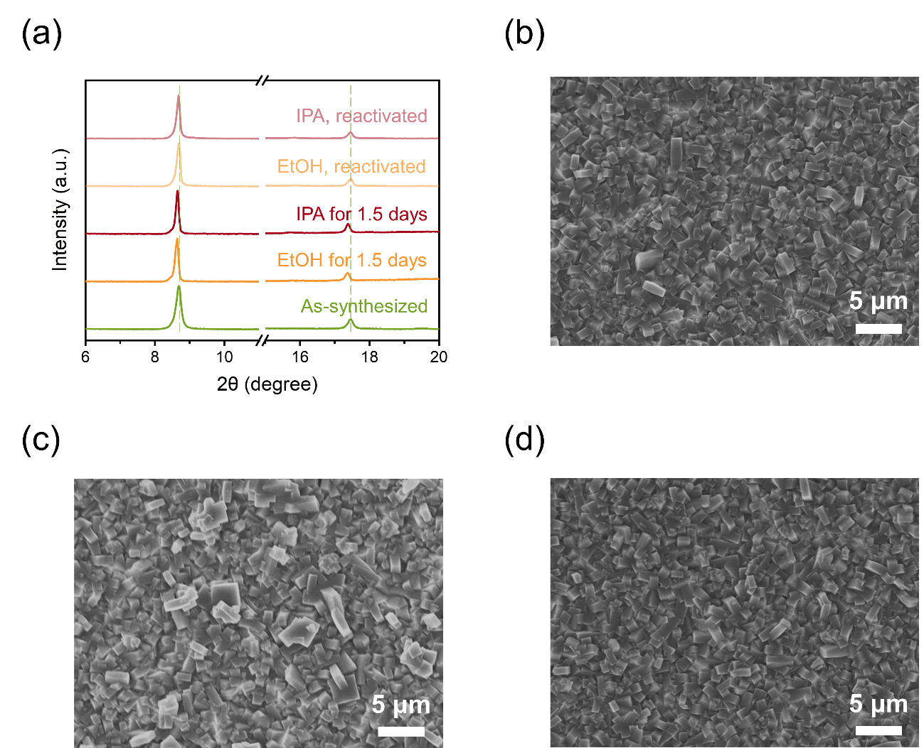

**Fig. S9.** (a) XRD patterns of the as-synthesized MOF-303 powder, those treated with ethanol or IPA, and those undergoing a thermal reactivation at 70 °C for 20 h. The XRD patterns shown in (a) were obtained using an in-house facility with X-ray at a wavelength of 1.5418 Å. SEM images of (b) as-synthesized MOF-303-urea membrane, (c) membrane treated with ethanol for 1.5 days, and (d) membrane undergoing the thermal reactivation. The crystal morphologies of MOF-303 in these images are nearly identical.

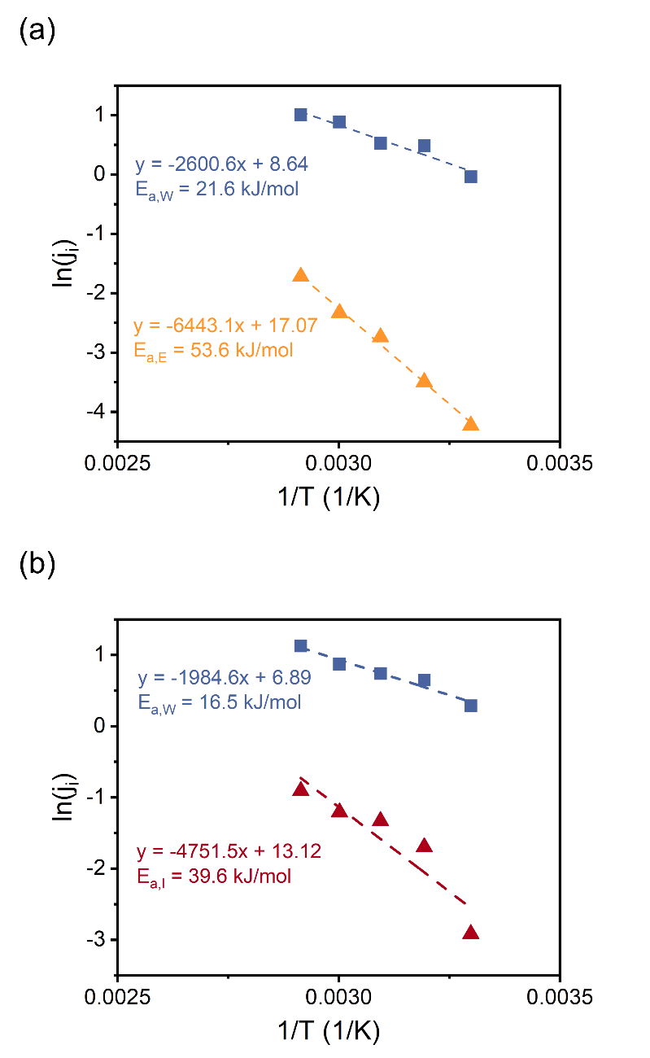

**Fig. S10.**  The Arrhenius plots for the molar flux (*ji*) obtained from pervaporation tests with 90 wt.% of (a) ethanol and (b) IPA. *Ea,W*, *Ea,E*, and *Ea,I* respectively represent the activation energies for the permeation of water, ethanol, and IPA. The values of activation energy were derived by fitting the data to the Arrhenius equation.

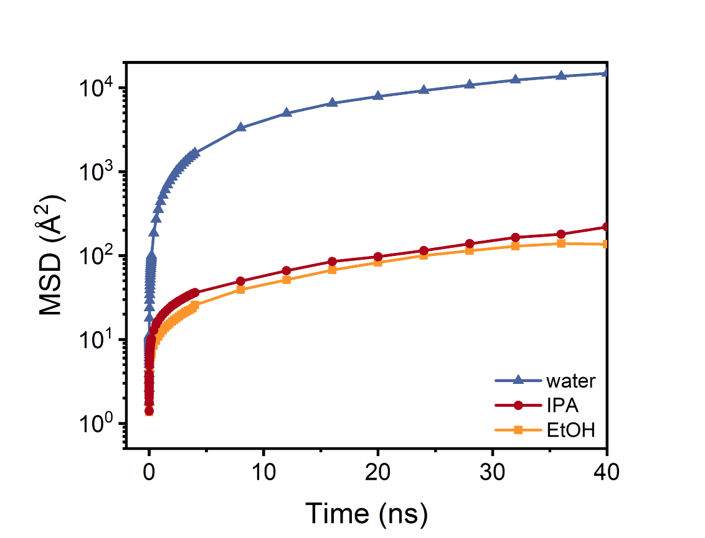

**Fig. S11.**  Mean squared displacement (MSD) versus simulation time for water, ethanol, and IPA at 333 K. The diffusion coefficients computed from the MSD are summarized in Table S3.

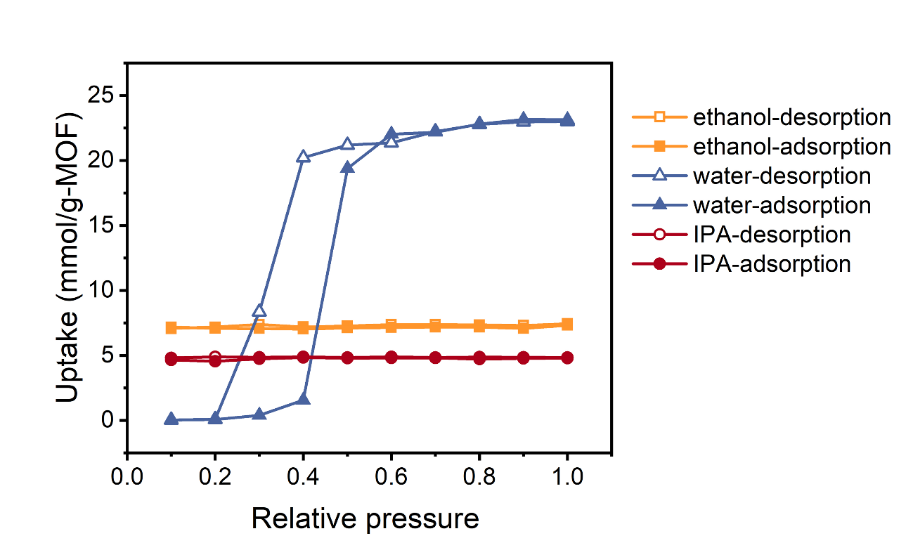

**Fig. S12.** Simulated adsorption-desorption isotherms of water, ethanol, and IPA in MOF-303 at 303K.

**Table S1.** Mole fraction, activity coefficient, and saturation vapor pressure used for the calculation of permeability of water, ethanol, or IPA at 333 K.

|  |  |  |  |  |
| --- | --- | --- | --- | --- |
| **Solution** | **Component** | ***xi***  **(-)** | ***γi***  **(-)\*** | **(kPa)\*\*** |
| 90 wt% of ethanol in water | water | 0.2213 | 2.030 | 19.94 |
| ethanol | 0.7787 | 1.035 | 47.00 |
| 90 wt% of IPA in water | water | 0.2704 | 2.303 | 19.94 |
| IPA | 0.7296 | 1.055 | 38.80 |
| pure water | water | 1 | 1 | 19.94 |
| pure ethanol | ethanol | 1 | 1 | 47.00 |
| pure IPA | IPA | 1 | 1 | 38.80 |

* The activity coefficient, *γi*, was computed using the modified UNIFAC model.

** The saturation pressure, ${ P}_{i}^{sat}$, was obtained using the Antoine equation.

**Table S2.** Mass flux and water/alcohol separation factor of pure MOF or zeolite membranes for pervaporation.

|  |  |  |  |  |  |
| --- | --- | --- | --- | --- | --- |
| **Material** | **Feed solution** | **Temperature**  **(K)** | **Flux (kg m-2 h-1)** | **Separation factor (-)** | **Reference number in main text** |
| Zeolite CHA | 90 wt% EtOH | 348 | 4.14 | 39500 | [87] |
| Zeolite CHA | 90 wt% IPA | 348 | 6.4 | 1600 | [90] |
| Zeolite LTA | 90 wt% EtOH | 348 | 3.94 | 5086 | [89] |
| Zeolite LTA | 95 wt% IPA | 348 | 1.12 | 5289 | [88] |
| CAU-10-H | 90 wt% EtOH | 313 | 0.397 | 324 | [67] |
| Sm-DOBDC | 92 wt% EtOH | 298 | 0.580 | 997 | [68] |
| Sm-DOBDC | 95 wt% IPA | 298 | 0.306 | 1881 | [68] |
| MIL-96 | 94 wt% EtOH | 333 | 0.125 | 6 | [85] |
| MIL-96 | 91 wt%  t-butanol | 333 | 0.081 | 16 | [85] |
| UiO-66 | 90 wt% EtOH | 343 | 3.73 | 55 | [65] |
| UiO-66 | 90 wt% IPA | 343 | 4.62 | 689 | [65] |
| Ni2(L-asp)2bipy | 90 wt% EtOH | 303 | 4.18 | 12.8 | [86] |
| Zn-aip-azpy | 90 wt% IPA | 303 | 0.077 | 452 | [69] |
| HLI | 90 wt%  ethanediol | 338 | 0.704 | 12000 | [84] |
| MOF-303-NaOH | 90 wt% EtOH | 303 | 0.213±0.064 | 8.9±2.9 | This work |
| MOF-303-NaOH | 90 wt% IPA | 303 | 0.465±0.266 | 5.5±3.9 | This work |
| MOF-303-Urea | 90 wt% EtOH | 303 | 0.032±0.011 | 55349±5534 | This work |
| MOF-303-Urea | 90 wt% EtOH | 313 | 0.055 | 25636 | This work |
| MOF-303-Urea | 90 wt% EtOH | 323 | 0.073±0.011 | 5887±2506 | This work |
| MOF-303-Urea | 90 wt% EtOH | 333 | 0.139 | 4502 | This work |
| MOF-303-Urea | 90 wt% EtOH | 343 | 0.168±0.020 | 1874±901 | This work |
| MOF-303-Urea | 90 wt% IPA | 303 | 0.034±0.001 | 3801±119 | This work |
| MOF-303-Urea | 90 wt% IPA | 313 | 0.081 | 622 | This work |
| MOF-303-Urea | 90 wt% IPA | 323 | 0.107±0.013 | 455±201 | This work |
| MOF-303-Urea | 90 wt% IPA | 333 | 0.137 | 257 | This work |
| MOF-303-Urea | 90 wt% IPA | 343 | 0.214±0.024 | 264±44 | This work |

**Table S3.** Adsorption uptakes and diffusion coefficients of water, ethanol, and IPA in MOF-303 obtained from simulations. The temperature in the simulations was set to be 333 K.

|  |  |  |
| --- | --- | --- |
| **Adsorbate** | **Adsorption uptake**  **(mmol g-1)** | **Diffusion coefficient** × 107  **(cm2 s-1)** |
| water | 22.2 | 382 |
| ethanol | 7.29 | 3.70 |
| IPA | 4.68 | 5.50 |